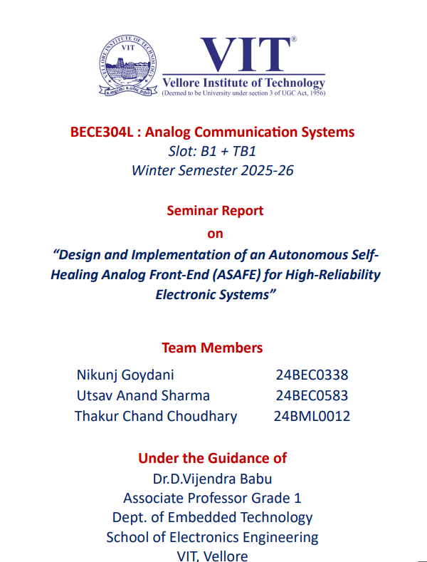

Introduction

Analog circuits are a part of modern electronic systems. They are used in things like signal conditioning and real-time data acquisition. Even though digital processing has gotten a lot better real-world signals are still continuous. This means they have to be processed in the analog domain before they can be converted and computed. So analog front-end circuits are very important for making sure entire systems are accurate and reliable. This is especially true in areas like instrumentation and wireless communication.

There are types of analog building blocks. One type is filters like the Sallen-Key topology. These filters are used a lot because they are simple and do not cost a lot. They are good for reducing noise and smoothing signals. However analog circuits have a problem: they are sensitive to changes in components and the environment. Things like resistors and capacitors can change over time. Get damaged. This can make a difference in how the filter works.

Usually people use hardware to make analog systems more reliable. This means they use circuits as backups. While this does make the system more fault-tolerant it also makes it more expensive. Uses more power. This is not good for systems like embedded devices. So there is a need for ways to make analog systems more reliable without using a lot of extra hardware.

In the few years people have started using something called self-healing analog circuits. These circuits can monitor themselves. Fix problems on their own. This is very important for systems that have to keep working all the time like systems in cars or drones. If an analog circuit fails it can cause problems.

This project is about making a self-healing analog filter. The filter is called ASAFE. It uses a microcontroller to monitor the filters output. If the output is not what it should be the system knows there is a problem. Then it can fix the problem.

The good thing about this approach is that it does not need a lot of hardware. It just needs an extra branch to fix the problem. This makes it cheap and efficient. The system also checks itself all the time to make sure it is working right. This way it can tell if a problem is temporary or permanent.

The goal of this project is to make sure the system keeps working even if it is not perfect. This is what people need in real-world applications. They need systems that can keep working even if something goes wrong. The system is also simple and easy to use so it can be used on embedded devices.

This project is about making analog filters work better. It does this by watching them finding problems and fixing them which makes the system work smoothly. The system has to be good, not too expensive and not too complicated so it can be used in a lot of situations. Analog filters like these are really important for things we use today. We use analog filters in things like equipment and phones.

If something goes wrong with the analog system this project shows how to make it fix itself. This way the system can keep working even if something breaks without needing a lot of hardware. This approach makes sure the system still works well when things go wrong and it can keep running. This makes the system more reliable. It also means we do not have to fix it as often which saves money. So this project gives us an practical way to make analog filters work better in real life situations.

Scope

Scope The self-healing analog filter system is becoming very important for making analog front-end circuits more reliable in embedded and communication systems. This system is not about finding faults it also helps make analog electronics work on their own adapt to changes and keep working even if something goes wrong all in real-time.

Key Areas of Future Research & Application

Reliable Analog Front-End Systems: The self-healing analog filter system can help make critical analog front-end circuits more reliable in areas like sensor interfaces, biomedical devices and communication systems where signal quality is crucial.

Iot and Edge-Based Monitoring: This system can work with IoT systems to monitor the health of analog circuits remotely. Microcontrollers like ESP32 can be used in edge devices for real-time diagnostics and self-recovery.

Extension to Multiple Fault Types: Future research can focus on types of faults like capacitor failures, op-amp degradation and multiple component faults to make the system even more robust.

Adaptive Threshold and Smart Detection: Using adaptive threshold mechanisms can improve fault detection accuracy, when environmental conditions like temperature and noise change.

Low-Cost Fault-Tolerant Design: The self-healing analog filter system can be used to create cost- alternatives to traditional systems that use redundancy especially in embedded platforms with limited resources.

Integration with AI-Based Predictive Maintenance: Combining this system with machine learning can enable fault detection allowing the system to anticipate and prevent failures.

Scalability to Complex Analog Systems: The self-healing approach can be applied to complex analog systems, like higher-order filters, multi-stage systems and complete analog signal processing chains.

Applications in Mission-Critical Systems: The self-healing analog filter system has potential in areas, like automotive electronics, aerospace systems, industrial automation and remote sensing where continuous operation is essential.

Literature Survey

Traditionally, improving the reliability of analog circuits meant using extra pieces of hardware to have back-up circuits in place should any of the original circuits fail. Although this was an effective solution, it introduced additional costs, increased power consumption, and caused the overall size of each circuit to become larger.

To help minimize some of these limitations, Built-In Self Testing (BIST) and calibration procedures were developed. BIST and calibration allow for a circuit to be able to test and fix itself internally when an error occurs. However, BIST and calibration typically are very complicated to design and often require using other pieces of hardware in conjunction with the actual circuit.

Subsequently, there have been newer techniques created that monitor the circuit outputs for any abnormal behaviour while the circuit is running (concurrent error detection and monitoring). This method provides a much more effective means of error detection, however, it can be complicated to design the required hardware in low-cost systems due to the computational requirements associated with implementing these systems.

The current state of research is focusing on self-repairing analog circuits; which allow an analog circuit to have real-time monitoring along with mechanisms that will allow the circuit to adapt to recover from operation. The proposed solution utilizes partial redundancy or reconfiguration to allow the circuit to maintain its performance to an acceptable level without needing to have two complete copies.

This work improves reliability in analog filters by providing an economical, effective solution by implementing an independent microcontroller to monitor the performance of the analog circuit and provide a specific threshold for error detection; and an impedance matched recovery path to the circuit.

Methodology
The proposed ASAFE system follows a closed-loop pipeline comprising four principal stages: filter design, fault monitoring, decision logic, and impedance-matched recovery. Each stage is designed with resource-constrained embedded deployment in mind.

A. Base Filter Design: Sallen-Key Low-Pass Filter
The base circuit is a second-order Sallen-Key low-pass filter, implemented using discrete passive components and a standard operational amplifier. Under nominal operation, the filter exhibits a DC output voltage in the range of approximately 1.25–1.33 V, depending on component tolerances and supply conditions. The ideal transfer function of the unity-gain Sallen-Key stage is:
H(s) = ω₀² / (s² + (ω₀/Q)·s + ω₀²)
where ω₀ is the natural frequency and Q is the quality factor. In practice, op-amp gain-bandwidth limitations, PCB parasitics, and resistor-capacitor tolerances shift the effective ω₀ and Q, contributing to output operating margin variations.

B. Fault Model
The dominant passive fault modelled in this work is an open-circuit failure in resistor R1. This failure disrupts the intended feedback condition of the Sallen-Key stage, causing the output to collapse toward the noise floor (~0.08 V in experimental observations), rendering the filter stage unusable for downstream processing. The fault indicator variable F(t) ∈ {0, 1} represents effective loss of acceptable filter operation, prioritizing system-level availability over exact component-level fault physics.

C. Monitoring and Fault Detection
The ESP32 microcontroller performs output voltage monitoring using its onboard 12-bit ADC. A software moving-average filter is applied to the sampled output to reduce quantization noise and spurious glitch detections. The filtered estimate Vout[k] is continuously evaluated against static threshold bounds:
Vmin ≤ Vout(t) ≤ Vmax where Vmin = 0.50 V, Vmax = 1.65 V
A debouncing mechanism requires Nc consecutive out-of-window samples before the state machine escalates from 'healthy' to 'recovery-triggered'. This prevents false alarms from transient noise spikes or ADC quantization effects.

D. Decision Logic and State Machine
The firmware implements a deterministic state machine with four states: healthy, suspect, recovery-active, and revalidation. State transitions are governed by:
Sk+1 = T(Sk, Vout[k], τPHC, Nc)
where T is a deterministic transition map and τPHC is the periodic health check interval. This formalization ensures portability of the algorithm to other active filter topologies.

E. Impedance-Matched Recovery
Upon fault detection, a GPIO-controlled auxiliary branch with matched impedance characteristics is activated. Unlike full circuit duplication, only the critical compensation path is replicated. The recovery objective is to keep the effective driving-point impedance close to the nominal case:
|Zeq,nom(jω) − Zeq,rec(jω)| ≤ εz
Even if perfect impedance matching is not achievable, bounded mismatch is sufficient to restore output within the operational envelope. The switching action is synchronized with the ADC sampling cycle to avoid race conditions between measurement and topology changes.

F. Periodic Health Check (PHC)
Every 2.5 seconds, the controller temporarily re-evaluates the primary filter path. If the output returns to within the valid range, the auxiliary branch is disabled (transient fault case). If the output remains out of bounds, the redundant branch stays active (permanent fault case). This mechanism avoids unnecessary long-term use of backup resources and limits switching stress and power overhead. The PHC interval τPHC is configurable to balance response latency against fault persistence requirements.
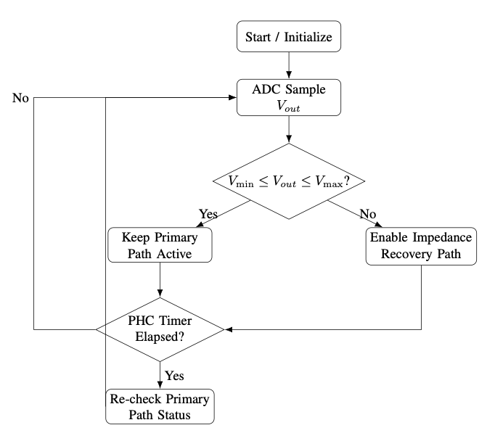

G. Recovery Efficiency Metric
System performance is evaluated using the recovery efficiency metric:
ηr = 1 − |Vnom − Vrec| / |Vnom − Vfault|
where Vfault is the post-fault output level before healing and Vrec is the recovered output level. Higher ηr indicates better restoration quality.

Hardware Setup

The setup includes the filter stage, sensing tap to ESP32 ADC, GPIO-controlled switching for the recovery branch, and a stable DC supply. The chosen values provide a nominal output around (1.25–1.33) V under healthy operation. Measurements were repeated to ensure consistency across runs. The physical implementation used for testing is shown in Fig. The board-level arrangement reflects the same control loop described in methodology section, where sensing, decision, and switching are integrated in one embedded platform

. 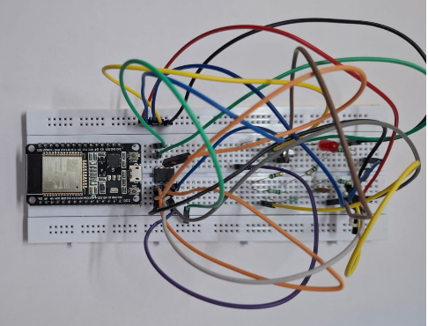

Results & Discussion

A. Normal-State Observations
Under nominal (non-faulted) operation, the filter output remained stable within the configured threshold window (0.50 V – 1.65 V), with measured values consistently near 1.30 V. The ESP32 monitoring loop generated no spurious fault flags during the healthy baseline, confirming that the chosen ADC path, moving-average filter, and threshold configuration are robust to routine quantization noise and minor supply fluctuations. The PHC supervisor remained passive, introducing no unnecessary switching events during normal operation.
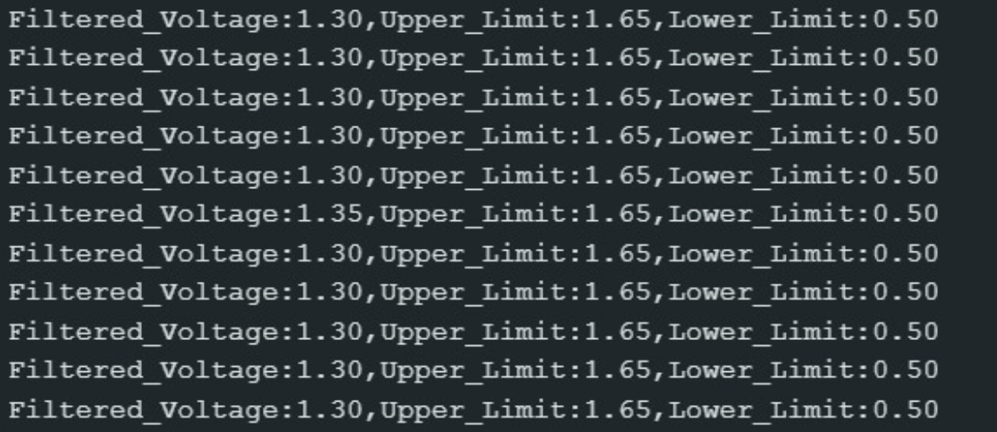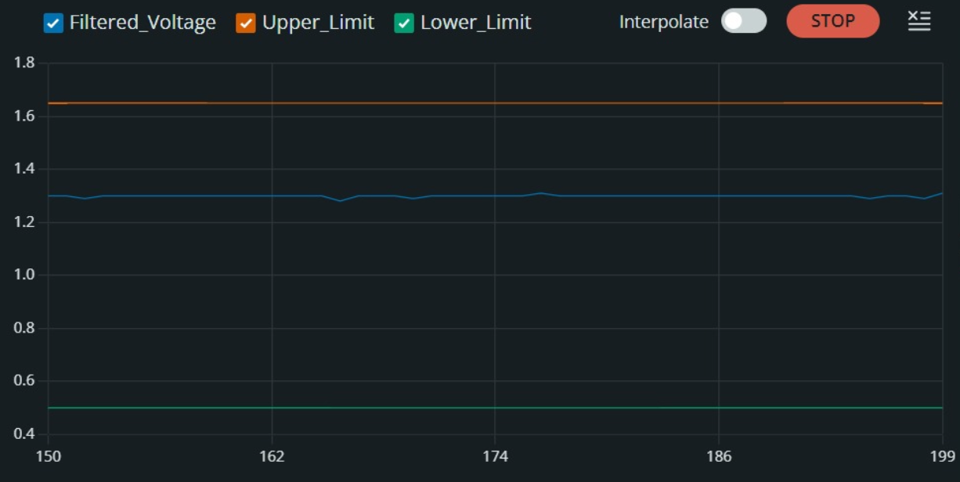

B. Fault Injection and Recovery
Upon injection of an open-circuit fault in R1, the filter output collapsed to approximately 0.08 V — well below the lower threshold of 0.50 V. The PHC logic detected the out-of-window condition within one monitoring cycle and triggered activation of the impedance-matched auxiliary recovery branch. The recovery trajectory showed a smooth rise from ~0.08 V to approximately 1.20 V, restoring the output to a level close to nominal without instability or oscillatory overshoot.

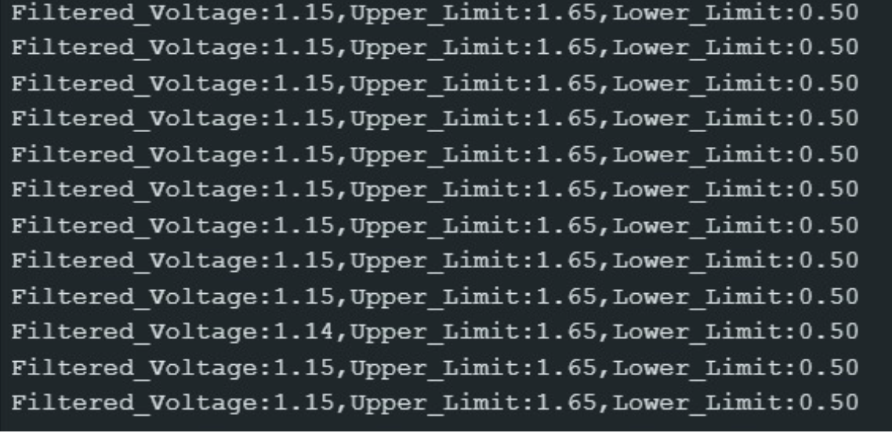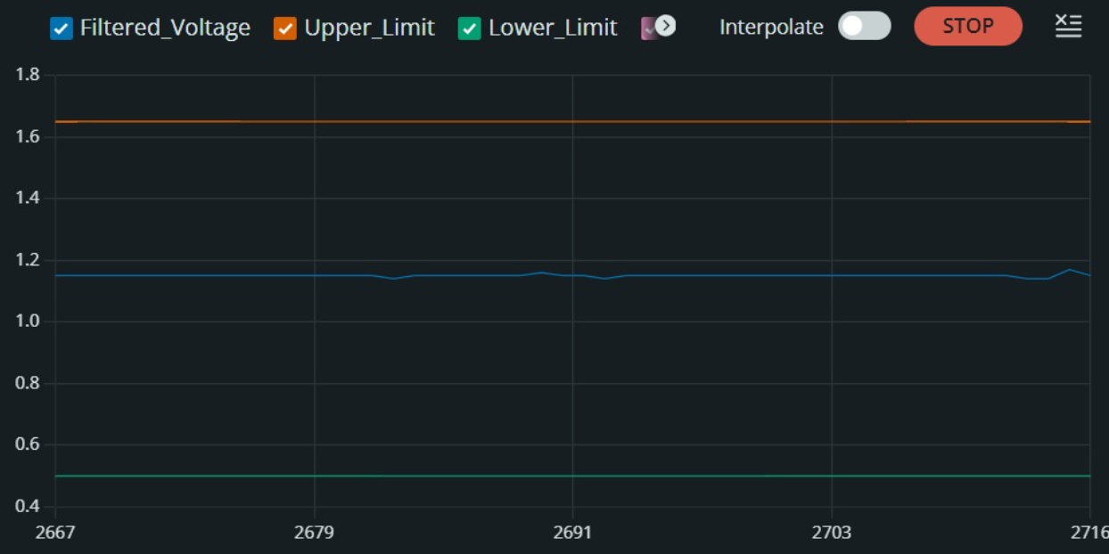
The complete experimental output summary across operating states is provided in the table below:

State | Typical Output (V) | Remark
Healthy (pre-fault) | 1.25–1.33 V | Within threshold window
Fault injected (R1 open) | ~0.08 V | Severe collapse / out-of-window
Recovered (aux path ON) | ~1.20 V | Restored to operational range

C. Quantitative Performance

The transition from a severe fault state to near-nominal range confirms that impedance-matched compensation can preserve functional continuity for downstream analog stages. While a residual DC offset remains, the resulting level is operationally acceptable for many cascaded systems. Recovery latency is bounded by detection and switching intervals and can be reduced by tuning sampling and PHC timing.

D. Practical Impact

From a system perspective, the key outcome is continuity of operation: the output remains useful after fault occurrence without manual intervention. This behavior is important for edge electronics where maintenance access is limited and uninterrupted sensing is required. Although full nominal re- construction is not achieved, the restored level substantially reduces fault impact and allows subsequent analog/digital stages to continue functioning. The observed behavior validates ASAFE as a practical compromise between reliability improvement and hardware complexity.

SDGs Addressed

SDG | Key Points
SDG 9 — Industry, Innovation & Infrastructure | AI-based self-healing circuits support 6G and next-generation wireless infrastructure. Adaptive analog front-ends reduce downtime and enable resilient, low-maintenance communication systems.
SDG 7 — Affordable & Clean Energy | Fault-tolerant low-power designs reduce the need for full hardware redundancy, improving energy efficiency. Self-healing circuits minimize power waste caused by component failures.
SDG 3 — Good Health & Well-Being | Self-healing analog circuits are critical in biomedical sensor interfaces and wearable devices. Reliable continuous operation prevents data loss in health-critical monitoring applications.

Conclusion
This work presented ASAFE, a low-overhead self-healing architecture for a Sallen-Key second-order analog low-pass filter. The proposed system combines ESP32-based real-time output monitoring, threshold-window fault detection with debouncing, and impedance-matched recovery branch switching. The periodic health check mechanism differentiates between transient and permanent faults, enabling resource-efficient redundancy management.
Experimental validation demonstrated recovery from a severe output collapse (~0.08 V post-fault) to a near-nominal level of ~1.20 V, achieving a recovery efficiency of approximately 90.3% with minimal hardware overhead compared to full circuit duplication. The system operated autonomously without manual intervention, with deterministic state machine logic that is auditable and portable to other low-order active filter topologies.
Future research directions include integration of edge-AI-assisted prognostics for predictive fault anticipation, dynamic threshold adaptation against temperature and noise, broader fault coverage for capacitor and op-amp failures, and eventual ASIC/SoC integration for compact mass-market deployment.

Acknowledgment
The authors are deeply grateful to Dr. Vijendra Babu D for his expert guidance throughout the research and development phases of this work. The authors also thank the Department of Electronics and Communication Engineering, VIT Vellore, for providing laboratory infrastructure and technical support essential to the hardware validation of this project.

References
[1] R. P. Sallen and E. L. Key, "A practical method of designing RC active filters," IRE Trans. Circuit Theory, vol. 2, no. 1, pp. 74–85, 1955.
[2] A. S. Sedra and K. C. Smith, Microelectronic Circuits, 7th ed. New York, NY, USA: Oxford Univ. Press, 2015.
[3] P. R. Gray, P. J. Hurst, S. H. Lewis, and R. G. Meyer, Analysis and Design of Analog Integrated Circuits, 5th ed. Hoboken, NJ, USA: Wiley, 2009.
[4] M. E. Van Valkenburg, Analog Filter Design. New York, NY, USA: Holt, Rinehart and Winston, 1982.
[5] A. Chatterjee, "Concurrent error detection in analog circuits," IEEE Trans. Comput.-Aided Design Integr. Circuits Syst., vol. 12, no. 8, pp. 1121–1131, 1993.
[6] C. Akbay and A. Chatterjee, "Self-healing techniques for analog electronic systems," in Proc. IEEE Int. Symp. Defect Fault Tolerance VLSI Syst., 2005, pp. 289–297.
[7] H. Yilmaz and S. Ozev, "Adaptive analog fault diagnosis and compensation," IEEE Trans. Instrum. Meas., vol. 59, no. 10, pp. 2683–2691, 2010.
[8] Espressif Systems, "ESP32 technical reference manual," Espressif, Shanghai, China, 2023.
[9] J. M. Park and H. Lee, "Calibration-aware ADC monitoring for embedded mixed-signal systems," IEEE Sensors J., vol. 18, no. 14, pp. 5890–5898, 2018.
[10] S. Gupta, R. Sharma, and P. K. Jain, "IoT-based condition monitoring for analog front-end circuits," in Proc. IEEE Int. Conf. Internet Things, 2018, pp. 112–117.
[11] A. Verma, N. Patel, and T. S. Rosing, "Machine-learning-based predictive maintenance for electronic systems," IEEE Access, vol. 8, pp. 145205–145218, 2020.
[12] M. Khan and R. Bose, "Deep learning methods for electronics reliability assessment," in Proc. IEEE Int. Reliability Phys. Symp., 2020, pp. 1–6.
[13] S. Lin, Y. Zhao, and H. Wang, "AI-assisted fault diagnosis in mixed-signal circuits," Microelectron. Rel., vol. 104, pp. 113519, 2019.
[14] NASA Office of Safety and Mission Assurance, "Electronics reliability guidelines for aerospace systems," NASA Std., Washington, DC, USA, 2021.
[15] International Organization for Standardization, "ISO 26262: Road vehicles — Functional safety," Geneva, Switzerland, 2018.
[16] P. Horowitz and W. Hill, The Art of Electronics, 3rd ed. Cambridge, U.K.: Cambridge Univ. Press, 2015.

